**DYSA - Game Day Dugout Mom**

On game day, the Team/Dugout Mom needs to ensure: 1) the dugout remains organized, 2) players transition from offense to defense smoothly, 3) the kids are having fun, and 4) the kids are safe!

BEFORE GAME (Dugout setup)

**[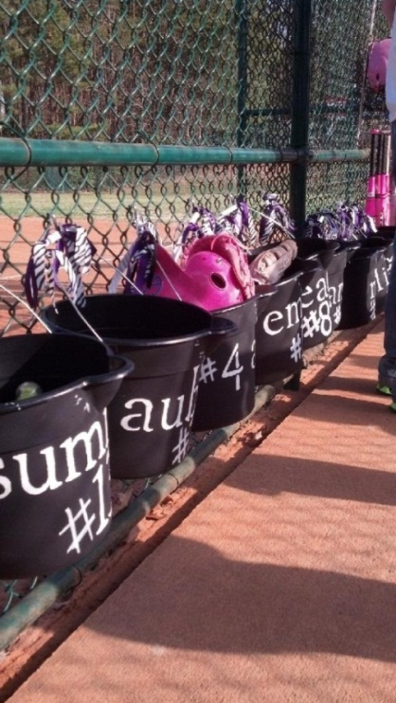](http://stopspoonfeeding.com/)Organize equipment & players**

* Make sure the banner is hung behind the batter box cage or alongside dugout
* Hang bats in the fence, inside dugout nearest batters circle
* Hang dugout buckets/place bins*in batting order along fence
* Kids fill their buckets (mitt, visor, water bottle, personal helmet)
* 8U and older, kids will usually have their own equipment bag – make sure those

are hung behind the bench

* Request from the coach, the player line-up and position rotation plan, so that you

can help the kids transition between innings quicker.

**TIP: *Buckets/bins for 6U/8U** will make life so much SIMPLER in the dugout for

the players! Write each player’s name visibly on each bucket. The kids love it,

and infield/outfield switching is much simpler!

DURING GAME (Offense and Defense)

**Time to bat… follow the Line-up**

* Players are either at bat, in the on deck circle, or sitting on the bench in their line up order
* 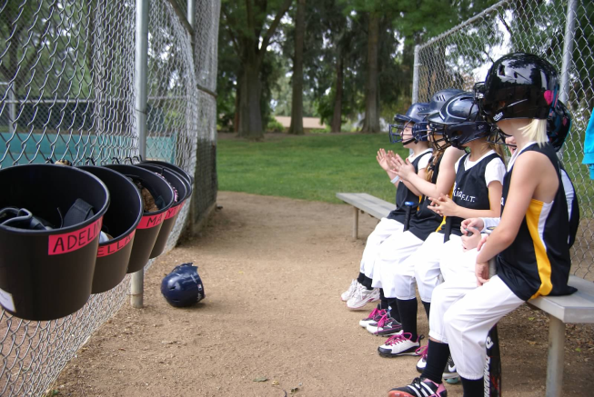In between batters, grab bat and keep dugout gate closed
* Insist that all players sit on the bench in their line up order
* Remind them to get ready, “Get your helmets on”
* In between innings, encourage hydration
* No snacks in the dugout; snacks come after the game!
* Encourage positive chanting
* Get kids relaxed before sending them into the ‘on deck’ circle
* As kids come in, keep moral high with High-5’s and talk, “Good hustle, “Good hit, “Good running, “Good swing!
* Younger kids need a lot more reminders and guidance – where is on deck, relax, keep your eye on the ball, run fast through first base after you hit the ball, … RELAX and HAVE FUN!

**Time to field… follow the Position Rotation plan**

* Remind kids what they need to do to get ready, “Get your visors, mitts,…” “Put helmets away in bins or bags…”
* Help kids know where to go each inning, following the coaches ‘fielding rotation plan’ (plan should be posted)
* Younger kids: need a lot more help… retying shoes, redoing pony tails, situating visors, don’t forget mitt! :)

AFTER GAME (Dugout purge)

* Another team is trying to get ready to play; as quickly as possible help remove bins and dugout contents
* Remind the snack parent to get setup away from the dugout
* At snack time, give bin contents back to parents (mitts, balls, water bottles, visors, personal helmets, jackets)
* Any team balls, helmets, bats that you pick up, please get to the coach
* Ensure banner is removed/returned to ‘Banner parent’

AT ALL TIMES (Safety comes first at games and practices!)

If a child or parent comes to you with a complaint about coach/parent behavior, or you are a first-hand witness to ‘egregious’ behavior by a coach/parent, then contact the DYSA Player Agent immediately. Issues will be handled as quickly and tactfully as possible, and you will have DYSA’s full support.

**DYSA Player Agent – John Schwarz at** [playeragent@davisyouthsoftball.org](mailto:playeragent@davisyouthsoftball.org)